Documentation of US_county_mortality
1. Cases and variables
The data focus on crude death rate of 5 kinds diseases in 3,142 counties in 2018. There are 11 variables and brief description shows as follow:
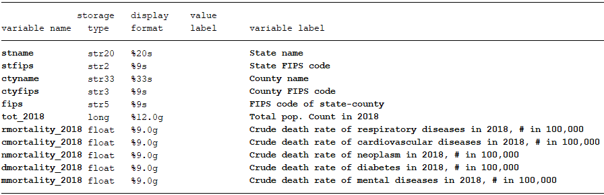

2. Data source
Raw statistics used to generate our data can be find in
https://wonder.cdc.gov/ucd-icd10.html
After clicking the button “I agree”, a window of “request form” will show. You can follow steps in https://wonder.cdc.gov/wonder/help/ucd.html to request form.

3. Raw data structure and something need to pay attention
Raw data collected from website of CDC looks like follow:
stfips | stname | ctyfips | ctyname | fips | c_population | cardiovascular_deaths | cardiovascular_crudeRate
1 | Alabama | 1 | Autauga County | 1001 | 55601 | 164 | 295
1 | Alabama | 3 | Baldwin County | 1003 | 218022 | 762 | 349.5
1 | Alabama | 5 | Barbour County | 1005 | 24881 | 125 | 502.4
1 | Alabama | 7 | Bibb County | 1007 | 22400 | 104 | 464.3
1 | Alabama | 9 | Blount County | 1009 | 57840 | 216 | 373.4
1 | Alabama | 11 | Bullock County | 1011 | 10138 | 46 | 453.7
1 | Alabama | 13 | Butler County | 1013 | 19680 | 105 | 533.5
Many variables are already here, but we use population from US_county_Pop.dta to replace population here since there are many missing values in this raw data and all non-missing value of population are equal to the value in US_county_Pop. Besides, there are many 0 in crude death rate, it may because of that the disease is secondary cause of death and its crude death rate goes underreported.

